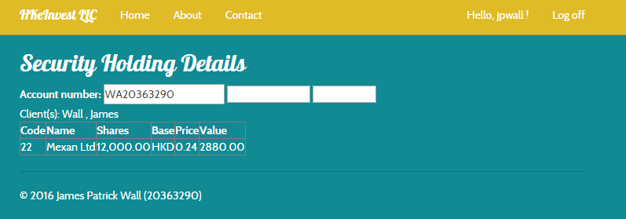

James Wall’s Submission for COMP 3111 Lab5 Part 1 (Student ID: 20363290)